

**Faculty Of Science and Technology**

**HIT140 FOUNDATIONS OF DATA SCIENCE**

**Lecturer**

**Yakub Sebastian**

**Group Project Report: Group 82**

**HOW DOES DIGITAL SCREEN TIME AFFECT WELL-BEING**

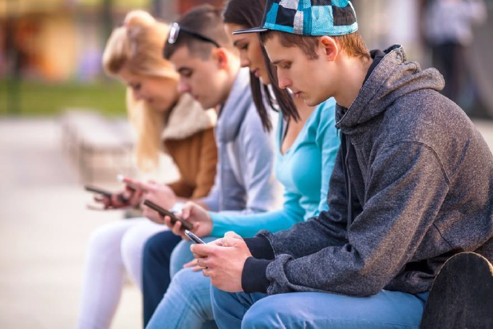

Thi To Nu Dinh S374680

Hoang Ha Le S377267

Dinesh Karki S377286

Nguyen Hao Vo S377196

*Casuarina Campus*

**Semester 2, 2024**

**GROUP MEMBER CONTRIBUTION REPORT**

|  |  |  |  |
| --- | --- | --- | --- |
| **Student Name** | **Student ID** | **Contribution** | **Signature** |
| Thi To Nu Dinh | S374680 |  |  |
| Hoang Ha Le | S377267 |  |  |
| Dinesh Karki | S377286 |  |  |
| Nguyen Hao Vo | S377196 |  |  |

Table of Contents

3. INTRODUCTION 5

3.1 Motivation 5

3.2 Objectives 5

4. DATA UNDERSTANDING 6

4.1 Dataset Description 6

4.2 Data Cleaning 7

4.3 Data Processing 8

4.3.1 Methodology 8

4.3.2 Exploring Data Analysis 9

5. PREDICTIVE MODEL AND RESULTS 18

6. DISCUSSION AND LIMITATIONS 26

6.1 Goldilocks Hypothesis (Moderate screen time for optimal well-being): 26

6.2 Activity Type (Different digital activities affect well-being differently): 26

6.3 Timing (Greater impact of screen time on weekdays): 26

6.4 Mental Well-being (Correlation between excessive screen time and well-being): 26

6.5 Regression Models (Linear vs. quadratic models): 26

6.6 General Limitations of Likert Scale Usage (Bhandari et al., 2024): 27

7. CONCLUSION 28

8. REFERENCES 28

**List of Tables**

*Table 1: DATA DESCRIPTION* 6

*Table 2: FINDINGS OF 3 RESPONDENTS' CATEGORY* 9

*Table 3: AVERAGE TIME spent on activities between weekdays and weekends* 10

*Table 4: gender's comparision* 14

**List of Figures**

*Figure 1: DATA CLEANING (CODE) AND CHECK* 7

*Figure 2: PIE CHART OF 3 RESPONDENTS' CATEGORY* 9

*Figure 3: Bar charts of 3 respondents' category* 9

*Figure 4: BAR CHART OF MEAN VALUES AND TREND LINES FOR WEEKDAY AND WEEKEND* 10

*Figure 5: Mean for Well-being indicators score* 11

*Figure 6: Computer vs Well-being of genders* 12

*Figure 7: GAMING VS WELL-BEING OF GENDERS* 12

*Figure 8: smartphone vs. well-being OF GENDERS* 13

*Figure 9: tv VS WELL-BEING OF GENDERS* 13

*Figure 10: Weekdays and weekend of 4 digital screen* 14

*Figure 11: Weekdays and weekend of 4 digital screen* 14

*Figure 12: correlation heat map of 3 datasets* 15

*Figure 13: Histogram of total wemwbs with kde, mean, median, mode, std DEV* 16

*Figure 14: Probability plot* 17

*Figure 15: COMPARISON OF DAILY SCREEN TIME BY GENDER ACROSS FOUR DIFFERENT DEVICES* 18

*Figure 16: Initial model summary* 19

Figure 17. Predict vs actual values 20

Figure 18. Model summary after removing C_wk, G_wk, S_wk and T_wk due to multicollinearity 21

Figure 19. Predict vs actual values after removing variables 22

Figure 20. Model Summary using newly created variables 23

Figure 21. Predict vs Actual data after dealing with multicollinearity 24

Figure 22. Model Summary with control variables 25

# INTRODUCTION

## Motivation

Concerns over the possible impacts of teenage digital screen time on their mental health have been raised by the growing prevalence of this behavior. Minimizing screen usage may have a good effect on behavior and mental health, according to recent studies. Considering how commonplace digital gadgets are, it is essential to comprehend the connection between screen time and well-being to guide suggestions for better digital behaviors. To gain important knowledge that can direct actions to support the best possible mental health, this study investigates the effects of various screen activities on the well-being of teenagers.

## Objectives

This report looks at usage trends, gender disparities, and the relationship between digital screen time and adolescents' well-being. Regression analysis is used to predict well-being ratings. The purpose is to offer guidance for enhancing adolescent well-being.

# DATA UNDERSTANDING

## Dataset Description

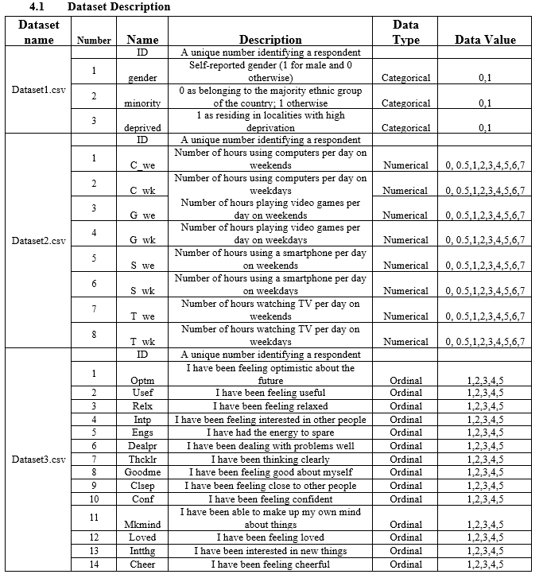

*Table 1: DATA DESCRIPTION*

## Data Cleaning

*Figure 1: DATA CLEANING (CODE) AND CHECK*

The main goal of the data cleaning process was to make sure that there were no duplicates or null values in the datasets before moving on to the merging stage. It was possible to reduce complexity and maximize resource usage by cleaning each dataset separately before joining them. Every dataset was analyzed in detail for duplicates and null values before being combined using an inner join with the ID field as the basis. “data.csv” is the file name of the finished cleaned dataset.

## Data Processing

### Methodology

##### About Warwick-Edinburgh Mental Well-being Scale (WEMWBS)

According to Tennant et al. (2007), the Warwick-Edinburgh Mental Well-being Scale (WEMWBS) is a validated measure of mental well-being that consists of 14 Likert-like items, each with 5 response categories ranging from "None of the time" to "All of the time." These items assess participants' feelings and mental states over a given period. Based on the identical naming of the variables, we inferred that the 5-point Likert Scale was used to collect the well-being data recorded in dataset 3. While WEMWBS with Likert item is technically ordinal, as it represents ranked responses, Tennant et al. (2007), Blodgett et al. (2022), and Marmara et al. (2022) have suggested that the Likert scale (combination of several Likert items to measure a construct) is frequently treated as continuous for analytical purposes in many studies. Therefore, in this report, we followed the same approach by creating a new "Overall Well-being score" (Total or Mean Score) dependent variable, which aggregates the 14 Likert items, and treated it as continuous data for the multiple linear regression analysis.

##### Linear Regression

Linear regression is a widely used statistical method that models the relationship between one or more independent variables and a continuous dependent variable. It excels at predicting outcomes where the relationship between the variables is assumed to be linear, making it highly interpretable and straightforward to apply. A key prerequisite for linear regression is assuming a linear relationship between the independent and dependent variables. Additionally, the model assumes that the residuals (errors) are typically distributed, homoscedastic (have constant variance), and independent. Hence, a multiple linear regression (MLR) model was developed to predict participants' well-being scores. The independent variables in this model include the time spent on four different screen types—TV, Smartphone, Gaming, and Computer—on both weekdays and weekends. The overall well-being score of participants was used as the dependent variable.

##### Model evaluation: R2 vs Adjusted R2

Chicco et al. (2021) stated, "The adjusted R-squared is a modified version of R-squared that has been adjusted for the number of predictors in the model." This adjustment corrects the potential overestimation of R-squared when non-informative predictors are included. The paper also acknowledged that adjusted R-squared addresses significant limitations of R-squared, particularly in multiple linear regression. Therefore, we evaluated our model using adjusted R-squared for a more accurate assessment of its predictive power.

##### Linear model optimization

Many different optimization techniques were applied to enhance the performance of the model. One critical issue addressed was multicollinearity, which has been proven by Akhtar et al. (2024) to compromise the stability and accuracy of parameter estimates in regression models. This occurs because multicollinearity, the presence of high correlations between independent variables, makes it difficult for the model to isolate the effect of each variable, leading to unreliable coefficient estimates and inflated standard errors. To resolve this, one effective approach is to remove one of the two highly correlated variables. Another method is to combine the correlated variables into a single new variable, which eliminates the multicollinearity without losing valuable data. This allows the model to capture the combined effect of both variables while avoiding the pitfalls of multicollinearity. Additionally, as noted by Spector (2021), the correct use of control variables can improve the performance of regression analysis. Control variables adjust for potential confounders, helping to isolate the effect of the main variables of interest and leading to more accurate and robust parameter estimates.

### Exploring Data Analysis

#### 4.3.2.1 Data distribution

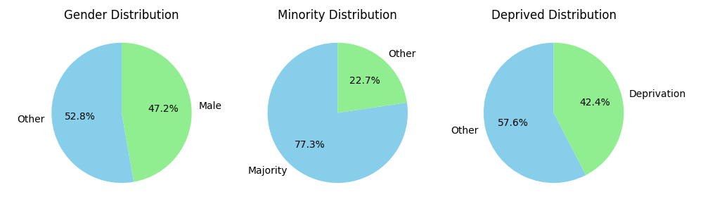

*Figure 2: PIE CHART OF 3 RESPONDENTS' CATEGORY*

*Figure 3: Bar charts of 3 respondents' category*

There are three key findings for the three groups above:

*Table 2: FINDINGS OF 3 RESPONDENTS' CATEGORY*

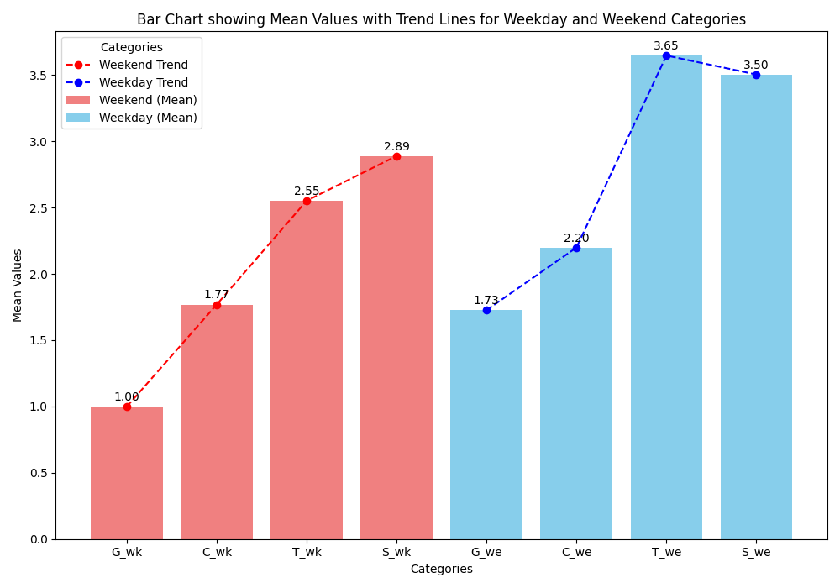

*Figure 4: BAR CHART OF MEAN VALUES AND TREND LINES FOR WEEKDAY AND WEEKEND*

1. Weekday vs. Weekend Comparison: The average time spent on activities during weekends is generally higher than on weekdays for all four devices:

*Table 3: AVERAGE TIME spent on activities between weekdays and weekends*

The minimum difference is 26 minutes on a computer, and the maximum difference is 1 hour and 6 minutes on TV. People engage more with these devices and weekend activities, especially TV.

2. Rising Trend: Both weekday and weekend trends show an increase in time spent as we move from video games, computers, and TV to smartphone use. The increase is steeper for weekends, particularly for TV, which jumps from 2.55 hours on weekdays to 3.65 hours on weekends.

3. Convergence in Computer Use: The time spent using the computer shows less variation between weekdays (1.77 hours) and weekends (2.2 hours), indicating a more consistent daily computer use regardless of the day of the week.

4. Visual Representation of Activity Time: The bar chart and trend lines visually reinforce that TV watching (32%) and smartphone use (34%) are the two activities that occupy the most time. Video game playing (13%) shows the lowest average time use on weekdays and weekends, indicating it may be a less frequent activity than the others.

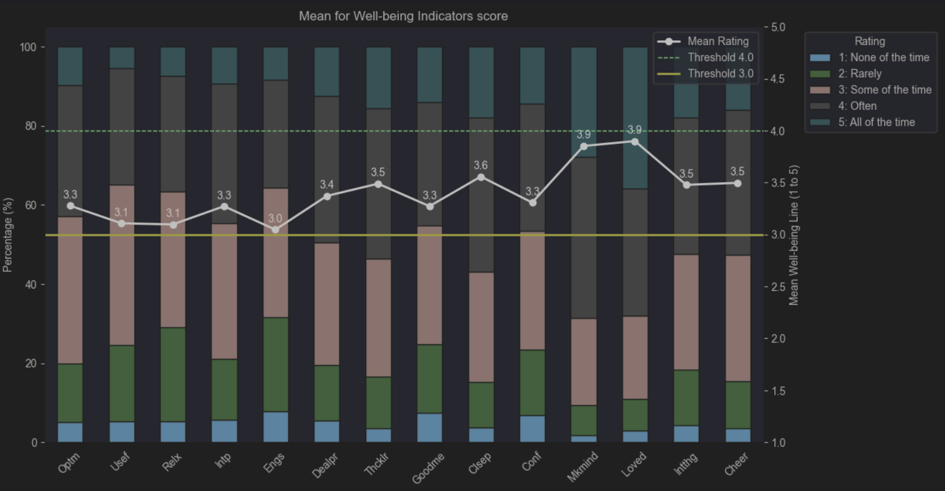

*Figure 5: Mean for Well-being indicators score*

Most Ratings Cluster Around "Some of the Time":

Many responses fall within the "3: Some of the time" category (pink), indicating that most students experience these well-being indicators moderately. This is particularly noticeable across all indicators, with slight variation in the stacked bar proportions. One of the many problems of the Likert scale is response bias, as participants often tend to choose socially desirable responses rather than providing accurate answers (Bhandari et al., 2024).

Mean Ratings Hover Around 3.0 to 3.9:

The mean rating line (white) mostly stays between 3.0 and 3.9, showing that the overall perception of well-being indicators lies between "Some of the time" and "Often." The highest rating is 3.9 for one of the indicators (possibly indicating a more positive outlook), while the lowest is 3.0.

Variation Across Well-being Indicators:

Some indicators, such as those with means near 3.9, suggest higher satisfaction or well-being levels in those areas. In contrast, indicators closer to 3.0 may indicate areas where well-being is perceived as lower or less frequent.

No Indicators Exceed the 4.0 Threshold:

None of the well-being indicators reach the 4.0 threshold, meaning no indicator consistently ranks as "Often" or higher in terms of well-being. This suggests a general room for improvement across all areas.

Notable Gaps Between Indicators:

Although most indicators are similar, there are a few outliers with slightly higher or lower scores. The indicator “Loved” has the highest extremity “5: All of the time response” portion in contrast with “Usef”. These could represent well-being areas where the population's experience diverges more, possibly requiring targeted interventions.

*Figure 6: Computer vs Well-being of genders*

Computer Engagement:

Males: Show stable well-being scores across weekdays and weekends, with a slight increase in weekend engagement. Well-being scores do not change much with higher computer use.

Non-Males: Similar pattern with slightly more weekend engagement but slightly lower well-being scores than males.

*Figure 7: GAMING VS WELL-BEING OF GENDERS*

Gaming Engagement:

Males: Show moderate, stable well-being scores, with consistent gaming engagement across both weekdays and weekends.

Non-Males: Engage less in gaming and have lower well-being scores, with more fluctuation in well-being when gaming time increases, especially on weekends.

*Figure 8: smartphone vs. well-being OF GENDERS*

Smartphone Engagement:

Males: Low weekday smartphone engagement, with a slight increase on weekends and a minor dip in well-being as engagement rises.

Non-Males: Engage more with smartphones, particularly on weekends, and see a noticeable drop in well-being with increased usage.

*Figure 9: tv VS WELL-BEING OF GENDERS*

TV Engagement:

Males: Show consistent TV engagement with a slight weekend increase and stable well-being scores.

Non-Males: Similar TV patterns but with a slight dip in well-being as engagement increases.

*Table 4: gender's comparision*

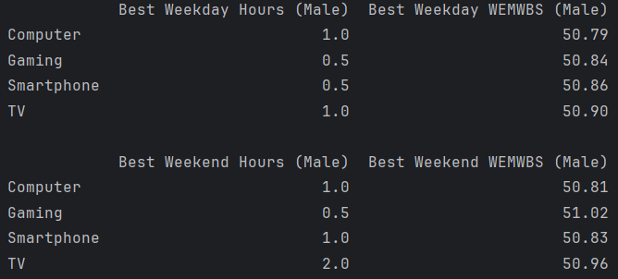

*Figure 10: Weekdays and weekend of 4 digital screen*

*Figure 11: Weekdays and weekend of 4 digital screen*

Goldilocks Hypothesis: Moderate screen use is "just right" for optimal mental well-being. Too little or too much screen time can be detrimental (Przybylski & Weinstein, 2017).

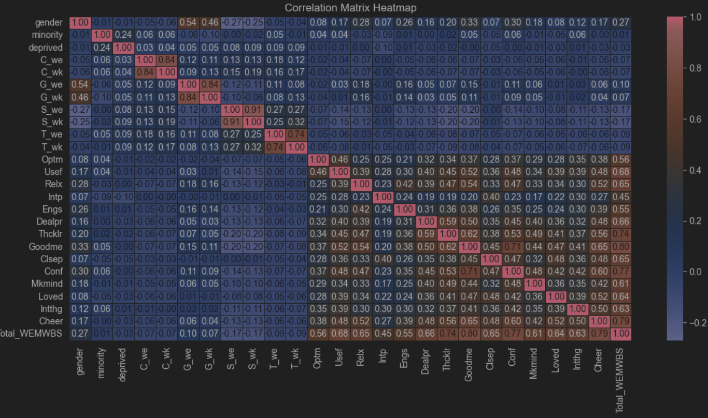

*Figure 12: correlation heat map of 3 datasets*

A correlation matrix was created to test for multicollinearity between control and dependent variables.

Each pair of time spent (weekdays and weekends) for each screen type (C, G, S, and T) heavily correlated with one another, indicating the existence of multicollinearity. Gaming and gender appeared to be mildly correlated. Total_WEMWBS correlates strongly with Goodme (0.80), Cheer (0.79), Conf (0.77), and Thcklr (0.77). This indicates that these components are major contributors to the overall score of Total_WEMWBS.

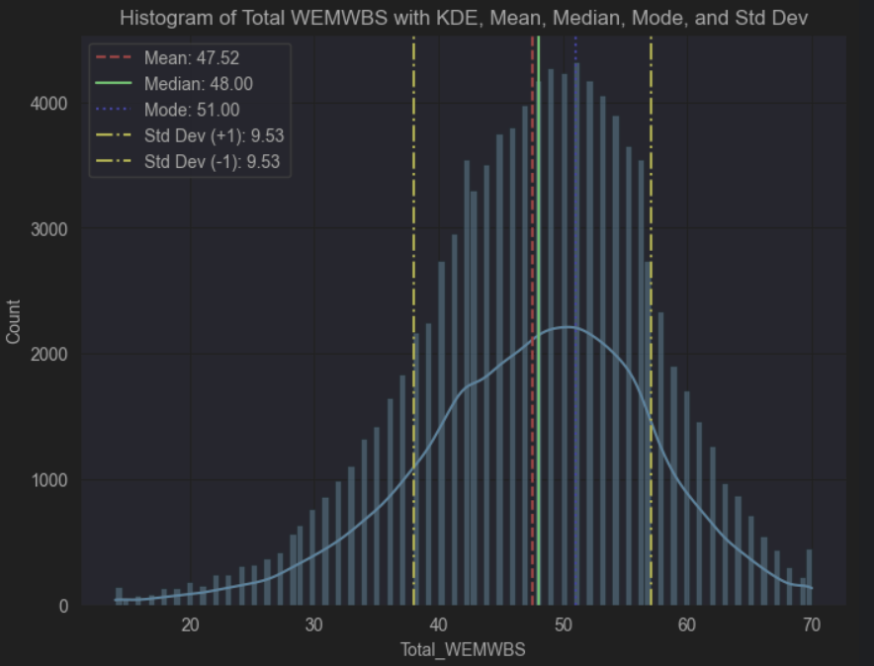

*Figure 13: Histogram of total wemwbs with kde, mean, median, mode, std DEV*

Distribution Shape:

The histogram shows a slight left skew, with the tail extending toward lower values.

Central Tendencies:

Mean: 47.52, slightly lower than the median, indicating left skew.

Median: 48.00, closer to the mode, reinforcing the skewness.

Mode: 51.00, the most frequent score, higher than both the mean and median.

Spread of Data:

Standard Deviation: 9.534, indicating most scores fall between 38 and 57 (mean ± standard deviation).

Implications of Skewness:

The left skew suggests lower scores pull the mean down, while many scores cluster around a higher value (mode). This highlights the presence of lower values affecting the overall well-being scores.

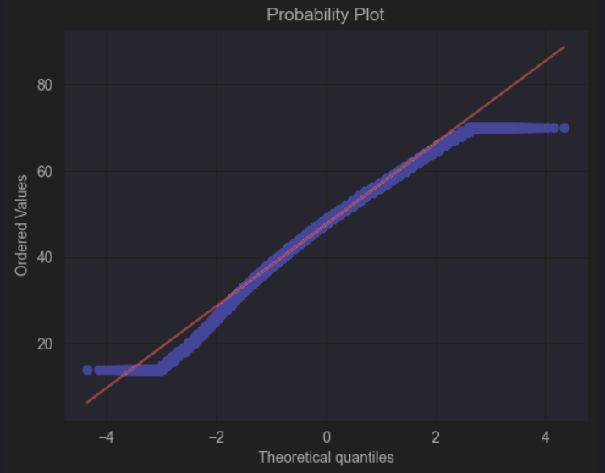

*Figure 14: Probability plot*

Probability Plot (Q-Q plot) that checks the normality of the dataset Total_WEMWBS.

Most of the data points fall close to the red line, indicating that the middle portion of the data follows a normal distribution fairly well. there are deviations at the extremes, indicating some non-normality, particularly in the distribution's tails. This suggests that the dataset might be slightly skewed and could benefit from a transformation if a normal distribution is required for further analysis.

#### 4.3.2.2 Data analysis:

##### Gender Comparison of Daily Screen Time across different devices:

*Figure 15: COMPARISON OF DAILY SCREEN TIME BY GENDER ACROSS FOUR DIFFERENT DEVICES*

In the category of computer use, women and other genders spend an average of 2.3 hours daily versus 2.09 hours for men, suggesting a marginally greater level of computer-related activity. Men spend an average of 2.96 hours a day gaming, compared to 0.63 hours for women and other genders. This is a considerable difference in time spent gaming between the sexes. Women and other genders are far more engaged with smartphones than men are; on average, they use them for 4.14 hours a day, compared to 2.8 hours for men. Lastly, when it comes to TV watching, women and other genders watch 3.73 hours of TV every day, compared to 3.55 hours for men.

In summary, women and other genders tend to use smartphones and computers more than men, while gaming is a predominantly male activity. TV watching is balanced between both genders.

# PREDICTIVE MODEL AND RESULTS

**Multiple Linear Regression**

To build the Linear Regression model, we partitioned the dataset, designating 60% for training. This training data was used to develop and calibrate the model by identifying relationships between the independent and dependent variables. The remaining 40% of the data was set aside as the testing set to evaluate the model's predictive accuracy and generalizability on new, unseen data.

**Initial model**

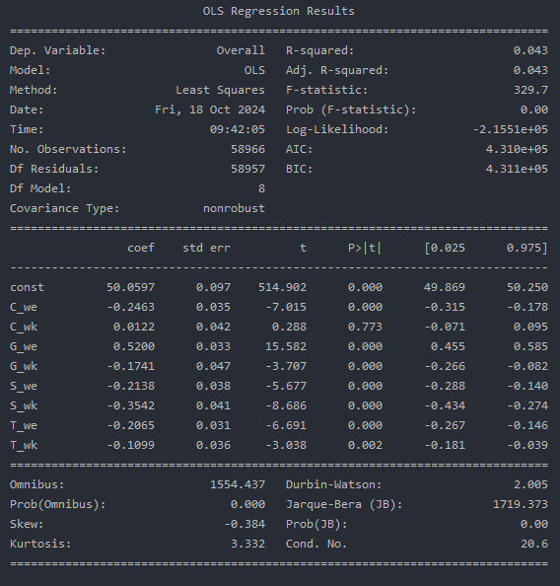

*Figure 16: Initial model summary*

The analysis results were generated using two main packages: statsmodels and sklearn. The multiple linear regression model is as follows:

Overall Well-being score = 50.0597 – 0.2463(C_we) + 0.0122(C_wk) + 0.5200(G_we) – 0.1741(G_wk) – 0.2138(S_we) – 0.3542(S_wk) – 0.2065(T_we) – 0.1099(T_wk)

The adjusted R-squared of the model is very low, at 0.043, meaning that it explains only about 4.3% of the variability of the response data around its mean. This indicates that the model may not fit the data well. Furthermore, the independent variable C_wk has a p-value of 0.773, greater than 0.05. This suggests that C_wk is not statistically significant in predicting the dependent variable in the context of this model and can be removed.

Figure 17. Predict vs actual values

When comparing the predicted values with the actual values from the test set, there appears to be a lack of accuracy

#### **Model Optimization**

#### Method 1: Remove multicollinearity

##### 1a. Removing correlated variables

According to the correlation heatmap, some independent variables should be removed due to their high correlation with each other. The revised model was rebuilt using only C_we, G_we, T_we and S_we as independent variables.

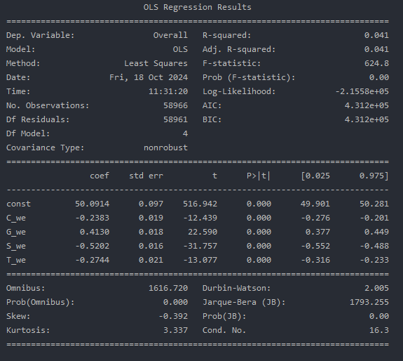

Figure 18. Model summary after removing C_wk, G_wk, S_wk and T_wk due to multicollinearity

The model is now: Overall Well-being score = 50.0914 – 0.2383(C_we) + 0.4130(G_we) – 0.5202(S_we) – 0.2744(T_we)

The adjusted R-squared have slightly decreased after removing half of the independent variables, indicating that the model has not improved.

Figure 19. Predict vs actual values after removing variables

##### 1b. Combining correlated variable

Instead of removing variables, we attempted to deal with multicollinearity by combining highly correlated variables. 4 new variables were created: C_daily, G_daily, T_daily and S_daily, each representing the average time spent per day on each screen type regardless of weekday or weekend. For example, C_daily was calculated as the weighted average of computer use over the week, using the formula:

C_daily = (C_we*2 + C_wk*5)/7

Figure 20. Model Summary using newly created variables

The model is now: Overall Well-being score = 50.0759 – 0.2633(C_daily) + 0.4783(G_daily) – 0.5778(S_daily) – 0.3229(T_daily)

5.3.2 Using Control Variables (Model 4)

Keeping the result from the previous optimization (removing multicollinearity by combining correlated variables), the model was optimized by including control variables from dataset 1.

Figure 21. Predict vs Actual data after dealing with multicollinearity

#### Method 2: Using Control Variables

Keeping the result from the previous optimization (removing multicollinearity by combining correlated variables), the model was further optimized by including control variables from dataset 1.

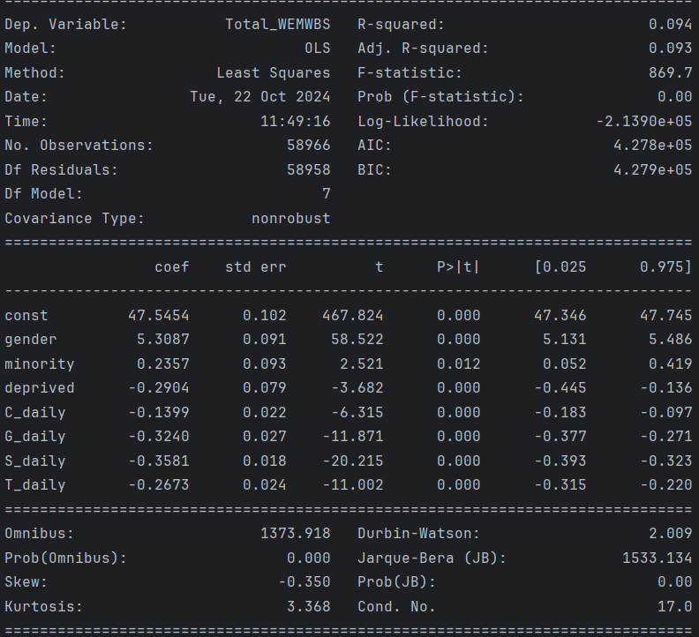

Figure 22. Model Summary with control variables

The model is now: Overall Well-being score = 47.5454 + 5.3087(gender) + 0.2357(minority) – 0.2904(deprived) – 0.1399(C_daily) – 0.3240(G_daily) – 0.3581(S_daily) – 0.2673(T_daily)

The adjusted R-squared value of our model has shown some improvement, now standing at 0.093 compared to its previous lower value.

This is the first 4 steps to improve the models. We also tried different steps as well but the R2 models do not improve at all—more models testing in the code file.

# DISCUSSION AND LIMITATIONS

## Goldilocks Hypothesis (Moderate screen time for optimal well-being):

Limitation: The "just right" concept of screen time is highly subjective and may vary significantly across different age groups, cultures, and socio-economic backgrounds. What constitutes moderate screen time for one individual may not apply to another, as this hypothesis oversimplifies a highly complex and individualized relationship. Additionally, this hypothesis does not account for the different types of content consumed during screen time. For instance, educational versus recreational screen time can affect well-being differently (Przybylski & Weinstein, 2017). Confounding factors such as physical activity levels, social interactions, and offline stressors may also be overlooked.

## Activity Type (Different digital activities affect well-being differently):

Limitation: Grouping digital activities into broad categories (e.g., watching TV, gaming) may not fully capture the nuance of how specific content affects well-being. For example, violent video games may have a different impact on adolescents compared to educational apps, yet they might both be classified under "gaming”. Moreover, self-reporting screen time activities can lead to biases, where participants may over- or under-estimate their engagement, affecting the reliability of the results. Longitudinal studies considering the long-term effects of different activities are limited in this research.

## Timing (Greater impact of screen time on weekdays):

Limitation: The study focuses on weekday versus weekend screen time without considering broader lifestyle factors, such as family environment and academic pressures (Przybylski & Weinstein, 2017). For instance, the impact of screen time may depend on whether it is school-related or for leisure. The effect of individual stress levels and the overall structure of adolescents' lives may moderate the relationship between screen time and well-being, yet this remains underexplored.

## Mental Well-being (Correlation between excessive screen time and well-being):

Limitation: The research relies heavily on correlation, leaving the direction of the relationship between screen time and well-being unclear (Przybylski & Weinstein, 2017). For example, adolescents with lower mental well-being may engage in more screen time as a coping mechanism rather than screen time, causing poor well-being. Furthermore, screen time alone may not be a sufficient predictor of well-being, as many other environmental, social, and emotional factors likely play a role. Assuming a linear relationship between screen time and well-being may not capture the more complex dynamics.

## Regression Models (Linear vs. quadratic models):

Limitation Without Adjustments: Linear models may oversimplify the relationship between screen time and well-being by not capturing curvilinear trends. The results may lack external validity without accounting for confounding variables such as family dynamics or pre-existing mental health issues. These variables could significantly influence the association between screen time and well-being.

Limitation With Adjustments for Control Variables: While adjusting for control variables such as gender, ethnicity, and socio-economic status reduces some biases, it may not address all relevant factors, such as individual personality traits or habits (Przybylski & Weinstein, 2017). Additionally, the reduction in statistical significance after adjustments suggests that the relationship between screen time and well-being may not be as strong or direct as initially believed.

## General Limitations of Likert Scale Usage (Bhandari et al., 2024):

Response Bias: Likert scales may introduce response bias, as participants often choose socially desirable responses rather than providing accurate answers.

Fatigue/Inattention: Respondents may experience fatigue or lose interest when answering a series of questions on a Likert scale, leading to inconsistent or inaccurate responses.

Subjective Interpretation: Some items may be too vague, causing respondents to interpret them differently. Words such as "Some of the time" may not have consistent meanings across respondents, affecting the reliability of results.

Restricted Choice: Likert scales limit responses to pre-defined categories, which can restrict respondents from expressing more nuanced feelings or perspectives.

# CONCLUSION

Initially, a multiple linear regression model was built to predict participants' overall well-being based on the time they spent on different screen types. However, the model's performance was suboptimal, prompting the application of optimization methods to improve it. Multicollinearity was detected, which can affect the stability of the model, so it was addressed in two ways: by either removing highly correlated variables or by combining them. Both approaches resulted in similar R-squared values, but combining variables proved superior since it preserved all variables in the model.

After incorporating control variables from dataset 1, such as demographic factors like gender, minority status, and deprivation levels, the model's performance improved slightly, but not significantly. The limited improvement in performance suggests that the control variables, while somewhat helpful, might not fully explain the relationship between screen time and well-being. This could indicate that other, unmeasured factors—such as lifestyle choices, mental health history, or social support—may significantly influence well-being.

# REFERENCES

Tennant, R., Hiller, L., Fishwick, R., Platt, S., Joseph, S., Weich, S., Parkinson, J., Secker, J., and Stewart-Brown, S. (2007). The Warwick-Edinburgh Mental Well-being Scale (WEMWBS): development and UK validation. Health and Quality of Life Outcomes, 5(1), p.63. doi:10.1186/1477-7525-5-63.

Blodgett, J.M., Birch, J.M., Musella, M., Harkness, F., and Kaushal, A. (2022). What Works to Improve Wellbeing? A Rapid Systematic Review of 223 Interventions Evaluated with the Warwick-Edinburgh Mental Well-Being Scales. International Journal of Environmental Research and Public Health, 19(23), p.15845. doi: 10.3390/ijerph192315845. PMID: 36497919; PMCID: PMC9737992.

Marmara, J., Zarate, D., Vassallo, J., et al. (2022). Warwick Edinburgh Mental Well-Being Scale (WEMWBS): measurement invariance across genders and item response theory examination. BMC Psychology, 10, p.31. doi: 10.1186/s40359-022-00720-z.

Akhtar, N., Alharthi, M.F., and Khan, M.S. (2024). Mitigating Multicollinearity in Regression: A Study on Improved Ridge Estimators. Mathematics, 12(19), p.3027. doi: 10.3390/math12193027.

Spector, P.E. (2021). Mastering the Use of Control Variables: the Hierarchical Iterative Control (HIC) Approach. Journal of Business and Psychology, 36, pp.737–750. doi: 10.1007/s10869-020-09709-0.

Chicco, D., Warrens, M.J., and Jurman, G. (2021). The coefficient of determination R-squared is more informative than SMAPE, MAE, MAPE, MSE and RMSE in regression analysis evaluation. PeerJ Computer Science, 7, p.e623. doi: 10.7717/peerj-cs.623. PMID: 34307865; PMCID: PMC8279135.

Mee, J., Pandian, R., Wolczynski, J., Morales, A., Paniagua, M., Harik, P., Baldwin, P., and Clauser, B.E. (2024). An experimental comparison of multiple-choice and short-answer questions on a high-stakes test for medical students. Advances in Health Sciences Education Theory and Practice, 29 (3), pp.783-801. doi: 10.1007/s10459-023-10266-3. PMID: 37665413; PMCID: PMC11208249.

Przybylski, A. K., & Weinstein, N. (2017). A Large-Scale Test of the Goldilocks Hypothesis: Quantifying the Relations Between Digital-Screen Use and the Mental Well-Being of Adolescents. *Psychological Science*, *28*(2), 204-215. <https://doi.org/10.1177/0956797616678438>

Bhandari, P. & Nikolopoulou, K. (2023, June 22). *What Is a Likert Scale? | Guide & Examples.* Scribbr. Retrieved October 21, 2024, from <https://www.scribbr.com/methodology/likert-scale/>